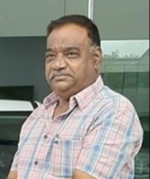

**STAFF PROFILE**

|  |  |  |
| --- | --- | --- |
| Name | : | **Dr.NAIKNAWARE BHAGAWAT PANDITRAO** |
| Designation | : | **Associate Professor** |
| Qualification | : | **B.Com.,B.P.Ed.,M.P.Ed.,Ph.D** |
| Experience | : | **09 Years** |
| **Sports Achievement** | | |
| Represented Inter-Collegiate Hockey Tournament 1985-1986 | | |
| Represented State Level Hockey Tournament 1984-1985 | | |
| **Publication** | | |
| **Particulars** | **National Level** | |
| Journals | 07 | |
| Books | 01 | |
| Conference | 03 | |